Software Design Document
for
QuickStay– A Smart Hotel Management System

Prepared by:

Adib Md. Mahin (301424034)
Azizullah Kimia Gul (301471636)
Mehmet Celal Suoglu (301442929)
Moesha Aurelle Emaleu Deutou (301444365)
Osamahiemen Idemudia (301476106)
Saqib Taha (301476435)

Centennial College November 2025

Submitted To
Prof. Sadit Zia Khan

Table of Contents
1 Part A: Project Scope and Requirements 3
Section 1: Problem Statement 3
1.1.a. Problem and Need 3
1.1.b. List of Capabilities and Benefits 4
1.1.c. Stakeholders and Their Roles 4
1.1.d. Subsystems 5
1.1.e. Intended Users 5
Section 2: Structured Modelling 6
2.1. Context Flow Diagram (CFD) of Smart Hotel Management System 6
Section 3: Functional Requirements and Use Case Diagram 6
3.1. Non-Functional Requirements 6
3.2 Goal Use Cases, Use Case Diagrams, and User Stories 7
Section 4: UML Domain Class Diagram 25
4.1 List of Classes 25
4.2 Domain Class Diagram 25
Section 5: ERD 27
Section 6: UML Systems Sequence Diagrams 29
Section 7: UML State Diagrams 31
State Machine Diagram for Booking Object 33
Section 8: Relevant Technologies 33
Section 9: Project Management 34
9.1 Grant Chart 35
2 Part B: Software Design Architecture 35
4.2. Domain Class Diagram 35
5. Section 5: ERD 36
6. Section 8: Relevant Technologies 36
Section 2: Overview Model 36
2.1 Intended Users of the SDD Document 36
2.2 Architectural Context Diagrams (ACD) 37
2.2.1 SRS Context Flow Diagram – CFD (What diagram) 37
2.2.2 Architectural Context Diagram -ACD (HOW diagrams) 37
Section 3: Modularization 39
3.1 Partition of the Analysis Model 39
3.2 Class Responsibility Collaboration (CRC) 42
3.3 Design Classes Diagram 50
Section 4: Framework Model View Controller 53
4.1 MVC Pattern Diagram 53
4.2 Sequence Diagrams (SD) 57
4.3 State Machine Diagrams 58
Section 5: Data Layer 61
5.1 Database Schema 61
5.2 Updated Technology List 66
Section 6: Grant Chart 68

Part A: Project Scope and Requirements

Section 1: Problem Statement

1.1.a. Problem and Need

Problems
The hospitality industry, whether small independent hotels, large international chains, luxury resorts, or business-focused city properties, faces common operational challenges. Many hotels still rely on outdated or fragmented systems (separate booking engines, manual spreadsheets, disconnected POS systems, and paper-based housekeeping checklists). This leads to:
- Overbookings and double reservations due to poor synchronization across booking channels.
- Revenue leakage from static pricing that fails to respond to occupancy, seasons, or demand surges.
- Operational inefficiencies such as delayed room readiness, miscommunication between departments, and lack of real-time updates.
- Long check-in and check-out times, frustrating guests, and overloading front-desk staff.
- Poor visibility in guest preferences and history, resulting in impersonal experiences.
- Limited scalability when hotels expand to multiple properties or integrate with global distribution systems (OTAs, corporate booking platforms).
- Compliance and security risks, especially around payment handling, data privacy (GDPR/CCPA), and PCI-DSS standards.
As guest expectations grow—demanding faster service, digital convenience, personalization, and transparency—traditional hotel management methods fall short.
Needs
Hotels of all sizes need a comprehensive, centralized Hotel Management System (HMS) that can:
- Unify operations across reservations, room management, housekeeping, front desk, and payments.
- Synchronize in real time across all channels (website, mobile app, front desk, OTAs, corporate systems).
- Provide self-service options (mobile check-in/out, e-keys, digital receipts, loyalty management).
- Enable dynamic pricing & revenue management (seasonal, event-based, occupancy-driven).
- Automate tasks such as housekeeping lists, maintenance alerts, and night audits.
- Support scalability for hotel groups and chains, managing multiple properties seamlessly.
- Offer role-based access & audit trails for accountability and compliance.
- Deliver data-driven insights (occupancy rates, ADR, RevPAR, guest demographics, cancellation trends).
- Ensure robust security & compliance for handling payments and personal guest data.

1.1.b. List of Capabilities and Benefits

To overcome these challenges, QuickStay introduces a smart, unified Hotel Management System (HMS) designed to optimize operations and enhance guest experience.
Capabilities of QuickStay:
- Centralized reservation management – Real-time room availability across all booking channels.
- Multi-channel support – Website, mobile app, front desk, and OTAs.
- Dynamic pricing engine – Automated adjustments for occupancy, seasons, and events.
- Guest self-service features – Online booking, e-check-in/out, digital receipts, loyalty programs.
- Integrated payments – Tokenization, refunds, transaction history, and compliance.
- Housekeeping automation – Room task lists and status updates in real time.
- Notification system – Booking confirmations, reminders, and promotional offers.

1.1.c. Stakeholders and Their Roles

Every hotel management system involves multiple groups, each playing a vital role in its success. The stakeholders for QuickStay include:

- Guests – Search for rooms, make bookings, check in/out, make payments, and leave reviews.
- Front Desk Staff (Receptionists) – Manage reservations, assign rooms, handle guest requests, and process payments.
- Housekeeping Staff – Maintain room readiness by updating statuses and following automated task lists.
- Maintenance Staff – Manage out-of-order rooms, log issues, and release rooms back into inventory once resolved.
- Hotel Manager/Admin – Configure rates, policies, and seasonal pricing; oversee staff operations; review performance reports.
- Finance/Accounting Staff – Handle reconciliations, invoices, refunds, and financial reporting.
- IT/Developers – Maintain technical integrations, upgrades, and system security.
- Payment Gateway – Securely process online transactions, refunds, and tokenization.
- Corporate Management – Monitor performance across multiple properties in hotel groups or chains.

1.1.d. Subsystems

QuickStay is designed as a modular system, where each sub-system focuses on a core area of hotel operations. The main functional components are:

- Reservation & Booking Management – Handles creating, modifying, cancelling reservations, check-ins/outs, and no-show policies.
- Room & Inventory Management – Tracks room status, housekeeping workflows, and maintenance updates.
- Guest Profile & Loyalty Management – Stores guest preferences, history, loyalty tiers, and requests.
- Staff & Access Management – Creates staff accounts, manages permissions, and tracks activity logs.
- Payments & Night Audit – Manages secure payments, refunds, daily audits, and financial exports.
- Dynamic Pricing & Revenue Management – Adjusts rates based on seasons, events, and occupancy thresholds.
- Notifications & Communication – Sends confirmations, reminders, in-stay updates, and promotional messages.
Reports & Analytics Dashboard – Provides data-driven insights into occupancy, revenue, and guest trends.

1.1.e. Intended Users

The intended users of the Software Requirements Specification (SRS) documentation include:

- Development Team Members: Responsible for implementing the software according to the specified requirements.
- Quality Assurance Testers: Ensuring the software meets all functional and non-functional requirements through rigorous testing.
- Project Managers: Overseeing the development process, ensuring timelines and objectives are met.
- Stakeholders and Investors: Evaluating the project's scope, objectives, and progress to make informed decisions about funding and support.

Section 2: Structured Modelling

2.1. Context Flow Diagram (CFD) of Smart Hotel Management System

Section 3: Functional Requirements and Use Case Diagram

3.1. Non-Functional Requirements

NFR # | Category | Description
NFR-1 | Security | All sensitive guest data (PII, payment tokens) must be encrypted at rest using AES-256-GCM and transmitted via TLS 1.2+. Passwords must be hashed with Argon2id.
NFR-2 | Performance | The system must process check-in/check-out operations within 3 seconds, and handle ≥ 200 concurrent booking requests without noticeable slowdown.
NFR-3 | Reliability & Availability | The system must maintain 99.5% uptime during hotel operations, with automated failover and backup recovery.
NFR-4 | Scalability | The HMS must scale to support 10,000+ reservations per month and handle multiple hotels or branches in the future without major redesign.
NFR-5 | Usability | Staff should be able to complete core workflows (e.g., reservation creation, check-in, payment posting) in ≤ 3 clicks with an intuitive interface.
NFR-6 | Auditability | All critical operations (price overrides, refunds, guest merges, role changes, data decrypts) must be recorded in an AuditLog with user, timestamp, action, and result.
NFR-7 | Compliance | The system must comply with PCI-DSS for payment handling and GDPR/CCPA for guest data protection.
NFR-8 | Maintainability | The codebase should be modular and documented so that bug fixes or new features can be deployed within 1 week without disrupting operations.
NFR-9 | Backup & Recovery | Database and files must be backed up daily with AES-256 encryption. Recovery Point Objective (RPO) ≤ 30 minutes; Recovery Time Objective (RTO) ≤ 2 hours.
NFR-10 | Accessibility | The guest-facing booking website must meet WCAG 2.1 AA standards for accessibility (screen readers, color contrast, keyboard navigation).

3.2 Goal Use Cases, Use Case Diagrams, and User Stories

Reservation / Booking Goal Use Cases

FR # | Goal Use Case | Role | Description
FR-R1 | Create reservation | Guest/Front Desk | Capture dates, room type, rate; hold/confirm booking.
FR-R2 | Modify/cancel reservation | Guest/Front Desk | Change dates/type/guests; apply policy; recalculate rate.
FR-R3 | Assign room | Front Desk | Allocate a clean, available room to a confirmed reservation.
FR-R4 | Check-in guest | Front Desk | Verify ID/payment; issue keys; set Checked-In.
FR-R5 | Room move/upgrade | Front Desk/Manager | Reassign; adjust rate if needed.
FR-R6 | Check-out guest | Front Desk | Close folio; finalize payment; set Checked Out.
FR-R7 | Request room type | Guest / Front Desk | Guest selects a preferred room type (Standard, Deluxe, Suite) when making reservation.
FR-R8 | Validate room type availability | System | System checks inventory for requested room type within chosen dates and confirms/denies request.
FR-R9 | Suggest alternatives | System | If requested type is unavailable, the system proposes alternative room types or dates.

Use Case Diagram

Reservation & Booking User Story
- User Story: Create Reservation
As a guest or front desk agent,
- I want to enter stay details (dates, room type, rate/plan),
- so that I can hold or confirm a booking.

Acceptance Criteria:
- System must capture guest contact information.
- System must request a guarantee or pre-authorization payment when required by the rate plan.
- System must validate policies (min/max stay, refundable/non-refundable).
- Reservation must be created in a "Held" or "Confirmed" status.
- A confirmation email or message must be sent automatically upon successful booking.

- User Story: Modify / Cancel Reservation
As a guest or front desk agent,
- I want to change or cancel my reservation,
- so that the details reflect my new plans.

Acceptance Criteria:
- Changing dates, room type, or number of guests requires revalidating room availability.
- The system must recalculate the rate automatically when changes are made.
- Cancelling must show the correct cancellation penalty (if any) before confirmation.
- Non-refundable rate plans must either block cancellation or clearly apply a 100% penalty.
- All changes and cancellations must be recorded in the audit log.

- User Story: Assign Room
As a front desk agent,
- I want to assign a clean, available room to a confirmed reservation,
- so that the guest has a specific room on arrival.

Acceptance Criteria:
- The system must only show "Clean" and "Available" rooms (not Occupied or Out-of-Order) for selection.
- Assigning a room must lock it in the system, removing it from the sellable inventory.
- The system must block any attempt at double-booking or assigning an unavailable room with an error message.

- User Story: Check-in Guest
As a front desk agent,
- I want to verify the guest's ID & payment, issue keys, and set their status to Checked-In,
- so that the guest can occupy their room.

Acceptance Criteria:
- Check-in must require a reservation with an assigned room and a valid payment guarantee/pre-authorization on file.
- On success, the reservation status must become "Checked-In".
- Electronic key encodings (e-keys) must be issued upon successful check-in.
- If payment fails or a room is missing, the system must block check-in and show clear next steps.

- User Story: Room Move/Upgrade
As a front desk agent or manager,
- I want to move or upgrade a guest to a different room,
- So that we can handle maintenance issues or offer paid upgrades.

Acceptance Criteria:
- The new room must be available and pass all policy checks.
- The system must propose a rate adjustment (pro-rated if mid-stay) and require confirmation before saving.
- Electronic keys must be updated to reflect the new room.
- The housekeeping department must be automatically notified of the move for cleaning.

- User Story: Check-out Guest
As a front desk agent,
- I want to finalize payment and close the folio.
- so that the reservation is completed and the room is prepared for the next guest.
Acceptance Criteria:
- All room charges, taxes, and incidentals must be posted to the folio.
- The system must collect any outstanding balance or process a refund.
- A final receipt or invoice must be generated for the guest.
- The room status must automatically transition to "Dirty" to alert housekeeping.

- User Story: Request Room Type
As a guest or front desk agent,
- I want to choose a preferred room type (e.g., Standard, Deluxe, Suite),
- so that the reservation matches my needs and preferences.

Acceptance Criteria
- The selection interface must list available room types with their capacity, amenities, and price.
- The chosen room type must be stored with the reservation and used in pricing and availability calculations.

Room Management (incl. Housekeeping & Maintenance) Goal Use Cases

FR # | Goal Use Case | Role | Description
FR-M1 | View room status map | Front Desk/ Housekeeping/  Manager | See Clean/Dirty/Occupied/OOO; filter/sort.
FR-M2 | Update room status | Housekeeping | Dirty → In-Progress → Clean → Inspected.
FR-M3 | Generate Housekeeping  task list | Manager/System | Auto-tasks from arrivals/departures; prioritize departures.
FR-M4 | Mark Out-of-Order (OOO) | Manager/Maintenance | Block assignment; record reason.
FR-M5 | Release OOO to inventory | Manager | Return room to sellable inventory.

Use Case Diagram

User Storie

- User Story: View Room Status Map
As a Front Desk Agent, Housekeeping Staff, or Manager,
- I want to view a visual map of all room statuses (Clean, Dirty, Occupied, Out-of-Order),
- So that I can quickly understand the current state of the hotel's inventory and make informed decisions.

Acceptance Criteria:
- The map must display rooms with color-coded or clear icons for Clean, Dirty, Occupied, and Out-of-Order statuses.
- Users must be able to filter the view by status (e.g., show only 'Dirty' rooms).
- Users must be able to sort rooms by number, type, or status.
- The map must update in near real-time when statuses are changed by other users.
- User Story: Update Room Status
As a Housekeeping Staff member,
- I want to update the status of a room (e.g., from Dirty to In-Progress to Clean),
- So that the front desk knows when a room is ready for a new guest and my task list is accurately reflected.

Acceptance Criteria:
- The system must provide a simple interface (e.g., dropdown, buttons) to change the room status.
- The status transition must follow a logical path (e.g., Dirty -> In-Progress -> Clean -> Inspected).
- Upon updating the status, the room map must be updated immediately.
- The system must log the user, timestamp, and status change for audit purposes.
- User Story: Generate Housekeeping Task List
As a Manager or Housekeeping Supervisor,

- I want to automatically generate a prioritized task list for the housekeeping team based on arrivals and departures,
- so that we can efficiently clean departure rooms first and ensure all rooms are prepared on time.

Acceptance Criteria:

The system must generate a list of rooms needing cleaning at the start of each day.

Rooms with guest departures (Check-Outs) must be prioritized at the top of the list.

The list must be accessible to housekeeping staff via their assigned devices.

The list should update automatically if there are last-minute changes or early departures.

User Story: Mark Out-of-Order (OOO)

As a Manager or Maintenance Staff,

I want to mark a room as Out-of-Order (OOO) and record the reason,

so that the room is blocked from being assigned to guests and the maintenance issue can be tracked.

Acceptance Criteria:

The system must prevent an OOO room from being assigned to any new reservation.

A mandatory field for the reason (e.g., "Plumbing," "AC Repair") must be filled when marking a room OOO.

The room must be clearly marked as OOO on the room status map for all staff.

The action must be logged in the audit trail.

User Story: Release OOO to Inventory

As a Manager,

I want to release a previously Out-of-Order room back to the sellable inventory,

so that we can maximize room availability and revenue once maintenance is complete.

Acceptance Criteria:

The system must change the room status from 'Out-of-Order' to 'Clean' (or another appropriate available status) upon release.

The room must immediately reappear in the available inventory for the front desk to assign.

A confirmation message must be displayed upon successful release.

The audit log must record that the room was returned to inventory.

Guest Management (profiles & loyalty)

Goal Use Cases

FR # | Goal Use Case | Role | Description
FR-G1 | Register/update guest | Front Desk/Guest | Create/update profile; contacts, IDs, prefs, loyalty.
FR-G2 | Search guest | Front Desk | Find by name/phone/email/loyalty; view history.
FR-G3 | Merge duplicates | Manager | Merge duplicate profiles with audit trail.
FR-G4 | Record special requests | Front Desk | Notes (allergies, late arrival) visible to depts.
FR-G5 | Manage loyalty tier | Manager | Enroll/upgrade/downgrade; apply benefits.

Use Case Diagram

Guest Management (profiles & loyalty) - User Stories
- User Story: Register / Update Guest Profile

As a guest or front desk agent,

I want to create or update a guest profile with contact details, identification, preferences, and loyalty information,

so that we can provide personalized service and accurate records for future stays.

Acceptance Criteria:

The system must allow for entering and saving guest details such as name, phone, email, address, and ID number.

It must be possible to record preferences (e.g., high floor, non-smoking, extra pillows).

The profile must be linked to the loyalty program upon creation or update.

All changes to a guest profile must be saved and reflected immediately in the system.

User Story: Search for a Guest**

As a front desk agent,

I want to** search for a guest profile by their name, phone number, email, or loyalty ID,

so that** I can quickly access their information during check-in, booking, or service requests.

Acceptance Criteria:

The search function must return matching results as the user types.

The search results must display key information like the guest's name and most recent stay date.

Selecting a guest from the results must display their full profile and booking history.

The system must handle partial matches and common misspellings.

User Story: Merge Duplicate Guest Profiles**

As a manager,

I want to merge duplicate guest profiles into a single, master profile.

so that we maintain a clean database and have a complete, accurate view of the guest's history and preferences.

Acceptance Criteria:

The system must allow a user to select two or more duplicate profiles to merge.

The user must be able to choose which data to retain from each profile (e.g., keep the primary email from profile A, keep the special requests from profile B).

The merge action must consolidate all reservation history and loyalty points.

A complete audit trail of the merge, including who performed it and what was changed, must be recorded.

User Story: Record Special Requests**

As a front desk agent,

I want to record special guest requests and notes (e.g., allergies, anniversary, late arrival),

**so that all relevant departments (housekeeping, kitchen, etc.) can be informed and deliver a superior guest experience.

Acceptance Criteria:

The system must provide a dedicated field in the guest profile and reservation for special requests.

These notes must be clearly visible to front desk and housekeeping staff when viewing the reservation or room assignment.

Critical alerts (e.g., severe allergies) must be prominently highlighted.

User Story: Manage Loyalty Tier

As a manager,

I want to enroll guests in the loyalty program, upgrade, or downgrade their tier, and apply corresponding benefits,

so that we can reward frequent guests and encourage repeat business.

Acceptance Criteria:

The system must allow manual enrollment of a guest into the loyalty program.

It must be possible to manually override a guest's tier (e.g., for a corporate partner or to resolve a complaint).

Upon tier change, the system must automatically apply the correct benefits (e.g., room upgrades, welcome amenities, late check-out) to current and future reservations.

All tier changes must be logged with a reason.

Profile (Staff) Management
Goal Use Cases

FR # | Goal Use Case | Role | Description
FR-P1 | Create staff user | Admin | Add user; set base role(s).
FR-P2 | Assign/update roles | Admin | Grant/revoke permissions per module.
FR-P3 | Lock/unlock account | Admin | Offboarding or policy violations.
FR-P4 | Update own profile | Any Staff | Change password/contact under policy.
FR-P5 | View audit log | Manager/Admin | Review sensitive actions (refunds, overrides, merges).

Use Case Diagram

Profile (Staff) Management - User Stories
- User Story: Create Staff User
As an Administrator,
- I want to create a new staff user account and assign a base role,
- so that new employees can access the system with permissions appropriate to their job function.

Acceptance Criteria:
- The system must provide a form to enter staff details (e.g., name, email, username).
- The administrator must be able to select a base role (e.g., Front Desk, Housekeeping, Manager) from a predefined list.
- The system must send a temporary password or setup link to the new user's email.
- The new account must be created in a "Pending" state until the first login and password change.
- User Story: Assign / Update Staff Roles
As an Administrator,
- I want to grant or revoke specific system permissions for a staff member,
- so that I can ensure staff have the access they need to perform their duties, and no more, following the principle of least privilege.

Acceptance Criteria:
- The system must display a list of all staff members and their current roles.
- The administrator must be able to modify a user's permissions per module (e.g., grant "Refund" permission to a Front Desk agent).
- Changes must take effect immediately upon saving.
- The system must prevent an administrator from removing their own administrative privileges.
- User Story: Lock / Unlock Staff Account
As an Administrator,
- I want to temporarily lock or permanently unlock a staff user's account,
- So that I can securely manage access for employees who are on leave, have violated policy, or have been terminated.

Acceptance Criteria:
- The administrator must be able to lock an account, which immediately prevents the user from logging in.
- A locked account must be clearly indicated in the staff management list.
- The administrator must be able to unlock the account, restoring the user's access with their existing permissions.
- All lock/unlock actions must be recorded in the audit log.
- User Story: Update Own Profile
As a Staff member,
- I want to update my own contact information and change my password,
- so that I can keep my details current and maintain account security.

Acceptance Criteria:
- Staff must be able to access and edit their own profile information (e.g., phone number, email).
- The system must require the user's current password to create a new one.
- New passwords must meet the company's security policy (e.g., minimum length, complexity).
- Changes to a user's own profile must not require administrator approval, except for role-sensitive fields.
- User Story: View Audit Log
As a Manager or Administrator,
- I want to review the audit log of sensitive actions performed in the system,
- so that I can monitor for policy compliance, investigate errors, and maintain accountability.

Acceptance Criteria:
- The system must provide a searchable and filterable view of the audit log.
- The log must include details such as the user who performed the action, timestamp, the action taken (e.g., "Price Override," "Guest Merge"), and the result.
- The log should be exportable for external analysis.
- Access to the full audit log must be restricted to Manager and Administrator roles only.

Payments & Night Audit

FR # | Goal Use Case | Role | Description
FR-P1 | Add payment method (tokenize) | Front Desk/Guest | Capture guarantee or pre-authorization.
FR-P2 | Post room/taxes & incidentals | System/Front Desk | Nightly room/tax posts; manual incidentals.
FR-P3 | Take payment/refund | Front Desk/Manager | Charge/split/refund with reason.
FR-P4 | Split folio | Front Desk | Move charges across guests/cards/folios.
FR-P5 | Night audit close | Manager | Validate blockers; lock day; produce reports/exports.

Payments & Night Audit - User Stories
- User Story: Add Payment Method (Tokenize)
As a front desk agent or guest,
- I want to securely capture and store a guest's payment method for guarantee or pre-authorization,
- so that we can secure the booking and facilitate faster check-in and checkout.

Acceptance Criteria:
- The system must integrate with a PCI-DSS-compliant payment gateway.
- Payment details (credit card) must be tokenized and stored securely; the system must never store full card numbers.
- A pre-authorization for an estimated amount must be placed on the card for guaranteed reservations.
- A confirmation of the successful tokenization/pre-auth must be displayed
- User Story: Post Room/Taxes & Incidentals
As the System or a front desk agent,
- I want to post charges for room rates, taxes, and additional incidentals to a guest's folio,
- so that all expenses are accurately tracked and billed to the guest.

Acceptance Criteria:
- The system must automatically post nightly room and tax charges during the night audit process.
- Front desk agents must be able to manually post incidental charges (e.g., minibar, restaurant, spa) with a description.
- All posted charges must be immediately visible on the guest's open folio.
- The running balance must update in real-time after every post.
- User Story: Take Payment / Refund
As a front desk agent or manager,
- I want to process a payment for charges or issue a refund to a guest's card,
- so that the guest can settle their bill or receive money back for overpayments or cancelled services.

Acceptance Criteria:
- The system must allow charging the full balance or a partial amount to a tokenized card.
- For refunds, the system must require a manager override or a reason code for audit purposes.
- The system must process the transaction through the payment gateway and provide a receipt.
- The folio must be updated to reflect the payment, reducing the outstanding balance to zero upon full settlement.
- User Story: Split Folio
As a front desk agent,
- I want to move specific charges to a different folio or payment method,
- So that we can bill separate companies, individuals, or cards for different parts of the stay.

Acceptance Criteria:
- The system must allow selecting individual charges (e.g., room charge, restaurant bill) from a folio.
- The agent must be able to move selected charges to another guest's folio or a new, separate folio.
- The system must recalculate the balances for all affected folios automatically.
- The original folio must retain a record of the transferred charge for auditing.
- User Story: Night Audit Close
As a Manager or Night Auditor,
- I want to run the night audit process to close the business day,
- so that daily financial reports are generated, the system date is advanced, and the hotel is ready for the next day's operations.
Acceptance Criteria:
- The system must validate that there are no critical errors (e.g., unposted payments, system imbalances) before proceeding.
- The process must automatically post room revenue and taxes for all staying guests.
- The system must "lock" the past business day to prevent any changes to its transactions.
- The audit must produce end-of-day reports, including a Daily Summary Report and a Trial Balance for the finance department.

Dynamic Pricing Goal Use Cases

FR # | Goal Use Case | Role Player | Description
FR-DP1 | Define rate plans | Manager | The manager can create and manage different rate plans (e.g., Standard, Non-Refundable, Corporate, Loyalty). Each plan includes a cancellation policy, refundability, min/max stay, and loyalty discounts.
FR-DP2 | Configure pricing rules | Manager | The manager can configure rules that affect pricing, including seasonality, day-of-week, events, and occupancy thresholds. These rules ensure that the system adjusts rates dynamically without manual intervention.
FR-DP3 | Auto-calculate prices | System | The system automatically calculates daily recommended rates for each room type by applying the configured rules (seasonal multipliers, occupancy factors, event surcharges). Runs nightly or when major demand changes occur.
FR-DP4 | Occupancy-based adjustments | System | The system applies discounts or surcharges when hotel occupancy crosses thresholds. Example: occupancy <40% → −10% discount; occupancy >80% → +15% surcharge. Thresholds and percentages are configurable.
FR-DP5 | Event/blackout management | Manager | The manager can mark blackout dates (no bookings allowed) or special events (festivals, conferences). On such dates, prices can automatically increase by a fixed percentage or amount.
FR-DP6 | Seasonal pricing | Manager / System | The manager can define seasonal periods (e.g., Summer Peak, Winter Low, Holiday Season) with associated pricing multipliers. The system automatically applies these seasonal rates during the specified date ranges.
FR-DP7 | Manual override with expiry & audit | Manager / Admin | Managers or admins can override system-calculated prices for specific dates/room types. Each override requires a reason and an expiry date. All overrides are logged, and the system automatically reverts to the calculated price when the expiry date is reached.

Use Case Diagram

Dynamic Pricing - User Stories
- User story: Define rate plan
As a Hotel Manager,
- I want to create and manage different rate plans (e.g., Standard, Non-Refundable, Corporate, Loyalty),
- so that I can offer guests a variety of booking options with different benefits and restrictions.

Acceptance Criteria:
- Each rate plan must include configurable attributes: cancellation policy, refundability, minimum and maximum stay requirements, and eligibility for loyalty discounts.
- It must be possible to activate or deactivate rate plans for specific dates.
- Changes to a rate plan must not affect existing, confirmed reservations.

- User Story: Configure Pricing Rules
As a Hotel Manager,
- I want to configure automated rules that adjust pricing based on factors like seasonality, day-of-week, local events, and occupancy thresholds,
- so that room rates optimize revenue without requiring daily manual intervention.

Acceptance Criteria:
- The system must allow the creation of rules with clear conditions (e.g., "If date is between Dec 20-Jan 5, then multiply base rate by 1.5").
- Rules must be able to stack or have a defined order of precedence.
- It must be possible to view and edit all active rules in a central dashboard.

- User Story: Auto-Calculate Prices
As the System,
- I want to automatically calculate the recommended daily rate for each room type by applying the manager's configured rules,
- So that prices are always competitive and aligned with market demand and hotel strategy.
Acceptance Criteria:
- The calculation must run nightly to set prices for future dates.
- The system must also re-calculate prices in real-time if a major demand change is detected (e.g., a large block of rooms is booked).
- The calculated prices must be clearly displayed as the default rates in the booking engine and reservation system.
- User Story: Occupancy-Based Adjustments
As the System,
- I want to automatically apply discounts or surcharges when overall hotel occupancy crosses pre-defined thresholds,
- So that we can stimulate demand during slow periods and maximize revenue during high demand.

Acceptance Criteria:
- The manager must be able to set occupancy thresholds and corresponding percentage adjustments (e.g., <40% occupancy triggers a -10% discount; >80% triggers a +15% surcharge).
- The system must monitor real-time occupancy and apply the adjustments instantly.
- The applied adjustment must be visible in the rate calculation breakdown for auditing.
- User Story: Event/Blackout Management
As a Hotel Manager,
- I want to mark specific dates as blackout dates (no bookings) or special event dates,
- So that we can manage inventory for groups or apply significant price increases during high-demand periods like festivals or conferences.

Acceptance Criteria:
- On blackout dates, the system must block all new bookings for the specified room types.
- For special event dates, the system must automatically increase prices by a fixed percentage or amount.
- The calendar must provide a clear visual indication of blackout and event dates.
- User Story: Seasonal Pricing
As a Hotel Manager,
- I want to define seasonal periods (e.g., Summer Peak, Winter Low) with associated pricing multipliers,
- so that our pricing strategy automatically reflects long-term seasonal demand patterns.

Acceptance Criteria:
- The system must allow the creation of seasonal periods with a start date, end date, and a pricing multiplier.
- The seasonal rate must be automatically applied to all dates within the defined period.
- Seasonal rules must integrate with other pricing rules (e.g., occupancy-based adjustments) correctly.
- User Story: Manual Rate Override
As a Manager or Administrator,
- I want to manually override the system-calculated price for a specific room type and date,
- So that I can handle unique situations, match a competitor's price, or offer a special promotion.
Acceptance Criteria:
- Each manual override must require a mandatory reason for the change.
- Every override must have an expiry date, after which the price automatically reverts to the system-calculated rate.
- All overrides, including the user, timestamp, old price, new price, reason, and expiry, must be logged in the audit trail.

Section 4: UML Domain Class Diagram

4.1 List of Classes

Hotel
- Room
- RoomType
- Guest
- Reservation
- Invoice
- Payment
- Staff
- HousekeepingTask
- MaintenanceRequest
- LoyaltyProgram

4.2 Domain Class Diagram

Domain Class Diagram

Section 5: ERD

ERD Diagram

ERD Explanation

Cardinality Relationships (Crow's Foot Notation):
One-to-Many (1:M) Relationships:
HOTEL_CHAIN (1) ── contains ── (M) HOTEL - One chain can have many hotels
HOTEL (1) ── has ── (M) ROOM - One hotel has many rooms
GUEST (1) ── makes ── (M) RESERVATION - One guest can make many reservations
RESERVATION (1) ── generates ── (1) INVOICE - One reservation generates one invoice
INVOICE (1) ── receives ── (M) PAYMENT - One invoice can receive multiple payments

Many-to-Many (M:N) Relationships (Resolved with Bridge Tables):

RESERVATION (M) ── books ── (N) ROOM
Bridge Table: RESERVATION_ROOM

Purpose: One reservation can book multiple rooms, one room can be booked in multiple reservations over time

STAFF (M) ── has ── (N) PERMISSION
Bridge Table: STAFF_PERMISSION

Purpose: Staff members can have multiple permissions, and permissions can be assigned to multiple staff
One-to-One (1:1) Relationships:

USER (1) ── extends_to ── (1) GUEST - One user account is associated with exactly one guest profile
USER (1) ── extends_to ── (1) STAFF - One user account is associated with exactly one staff profile

Key Design Features:

Primary Keys:

All tables have surrogate primary keys (*_id fields)
Consistent naming convention throughout the schema

Foreign Key Relationships:

Proper referential integrity maintained
Clear parent-child relationships established
Cascade delete/update considerations implied

Bridge Tables:

RESERVATION_ROOM: Resolves M:N between reservations and rooms
STAFF_PERMISSION: Manages role-based access control
RESERVATION_SERVICE: Handles additional services beyond room booking

Data Types:

VARCHAR for textual data with appropriate lengths
DECIMAL for monetary values with precision.
DATE/DATETIME for temporal data
INTEGER for numeric counts and identifiers
BOOLEAN for true/false flags
TEXT for large text content

Normalization Level:

The schema demonstrates 3rd Normal Form (3NF) with:
No transitive dependencies
All non-key attributes dependent only on the primary key
Proper separation of concerns through entity decomposition
Minimal data redundancy through relationship normalization

Section 6: UML Systems Sequence Diagrams

Make Reservation
System Sequence Diagram: Make Reservation

Check-in Guest

Update Room Status

Section 7: UML State Diagrams

Reservation Object Lifecycle

State Diagram: Reservation Object Life

Booking Object

State Machine Diagram for Booking Object

Section 8: Relevant Technologies
The QuickStay Hotel Management System will be developed using a modern, scalable technology stack. The following table outlines the specific technologies chosen for each layer of the application architecture.

Layer / Component | Technology | Justification & Details
Presentation Layer (Front-end) | HTML5, CSS3, JavaScript | For building the structure, style, and interactivity of the web application. Provides a cross-platform, accessible user interface.
 | ASP.NET Core MVC (Razor Views) | A server-side web framework for building dynamic web pages. Razor Views allow for clean, secure, and maintainable HTML generation.
Application Layer (Back-end) | C# | A powerful, type-safe, and object-oriented programming language ideal for building complex business logic.
 | ASP.NET Core MVC | A high-performance, cross-platform framework for building web applications and APIs. Provides built-in support for dependency injection, security, and the MVC pattern.
Data Access Layer | Entity Framework Core | An Object-Relational Mapper (ORM) that simplifies database operations by allowing developers to work with C# objects instead of writing raw SQL queries.
Data Storage Layer (Database) | Microsoft SQL Server | A robust, reliable, and scalable relational database management system (RDBMS). Perfect for handling structured data like reservations, guest profiles, and financial transactions.
External Services & APIs | Stripe API | A secure, PCI-DSS compliant payment processing platform. Used for handling credit card transactions, tokenization, and refunds.
 | Twilio API | A cloud communication platform for sending automated SMS notifications (e.g., booking confirmations, check-in reminders).
Hosting & Infrastructure | Microsoft Azure / AWS | A cloud platform for scalable and reliable hosting of the web application and database. Provides features for load balancing, auto-scaling, and disaster recovery.
Development Tools | Visual Studio 2022 | The primary Integrated Development Environment (IDE). Offers excellent support for C#, .NET, and SQL Server development.
 | Git & GitHub / Azure DevOps | For version control and collaborative source code management.

Section 9: Project Management

9.1 Grant Chart

Part B: Software Design Architecture

Section 1: Requirements Edits to Part A

4.2. Domain Class Diagram

The Domain Class Diagram from Part A has been refined to transition from an analysis model to a more detailed design model. The key corrections and updates include:

- Integration of Design Patterns: The diagram now explicitly shows the use of the Model-View-Controller (MVC) pattern, with the introduction of <<interface>> components for Controllers and Views for each major subsystem (e.g., ReservationController, RoomManagementView).
- Refinement of Class Relationships: Navigation arrows and multiplicities have been reviewed and clarified to better represent the relationships and messaging pathways between classes, as required for the design phase. For example, the relationship between Reservation and Invoice has been explicitly defined as one-to-one.
- Addition of System Interfaces: New interfaces for external systems were added, such as PaymentGateway <<interface>> and SMSNotificationService <<interface>>, to specify how the system will interact with third-party services.
- Clarification of Attributes and Methods: Attributes and methods have been added to key classes to fully support the functional requirements. For instance, the Room class now includes a status attribute and an updateStatus() method, and the Payment class includes amount, paymentMethod, and processRefund().

5. Section 5: ERD

The Entity-Relationship Diagram has been updated to ensure it perfectly aligns with the refined Domain Class Diagram and supports the system's data persistence needs.
- Schema Alignment: All entities and attributes in the ERD now have a direct correspondence to the classes and attributes in the updated Domain Class Diagram. For example, the room_status field in the ROOM table directly maps to the status attribute in the Room class.
- Bridge Tables: The bridge tables, such as RESERVATION_ROOM and STAFF_PERMISSION, have been verified to correctly resolve the many-to-many relationships identified in the class diagram.
- Data Types and Constraints: Data types have been specified with precision (e.g., DECIMAL(10,2) for monetary values, VARCHAR(255) for text fields) and necessary constraints (e.g., NOT NULL) have been added to ensure data integrity.
- Foreign Key Relationships: All foreign key relationships were double-checked to ensure proper referential integrity and to accurately reflect the cardinalities defined in the class diagram.

Section 8: Relevant Technologies

- The technology list has been updated and made more specific to reflect the architectural decisions made during the design phase.

Section 2: Overview Model

2.1 Intended Users of the SDD Document
The Software Design Document (SDD) for QuickStay is a technical blueprint intended for the following primary users:
- Developers & Software Engineers: They use the SDD to understand the system's architecture, module interactions, and class structures to guide the implementation and coding process.
- Quality Assurance (QA) Testers: QA teams use the design specifications to create detailed test cases, ensuring that each component and interaction works as designed.
- System Architects & Technical Leads: They review the SDD to validate the design decisions, ensure adherence to architectural patterns (like MVC), and guarantee the system meets all non-functional requirements (e.g., scalability, security).
- Project Managers: PMs use the document to track development progress against the designed components and to manage technical risks.

Architectural Context Diagrams (ACD)

This section provides the "HOW" overview, drilling down into the system's internal subsystems. It contrasts with the "WHAT" overview from Part A's Context Flow Diagram.

SRS Context Flow Diagram – CFD (What diagram)
This is the high-level "WHAT" diagram from Part A, included here for contrast.

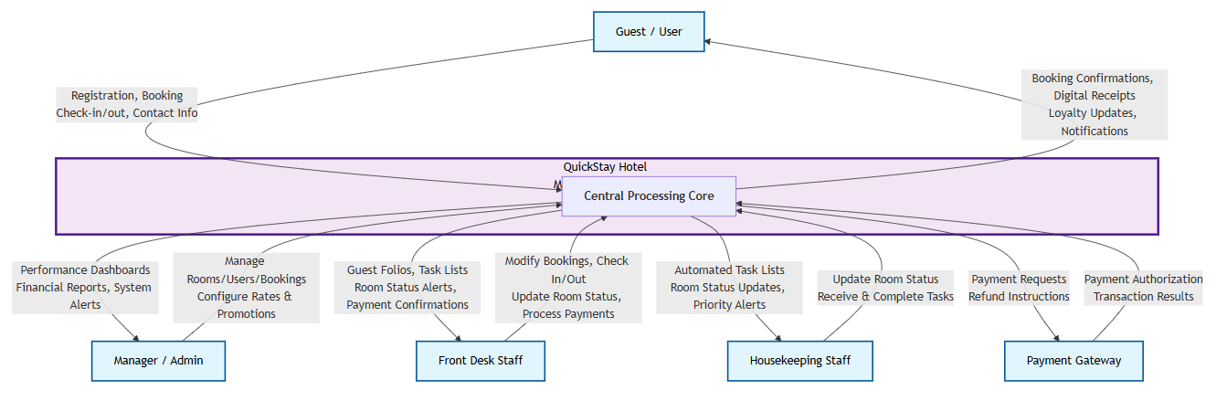

Architectural Context Diagram -ACD (HOW diagrams)

The following three diagrams show HOW the QuickStay system accomplishes its goals by detailing the interactions of its core internal subsystems.

ACD 1: Reservation & Booking Management Subsystem

This diagram shows how the reservation process is handled internally, involving price calculation, availability checks, and payment processing.

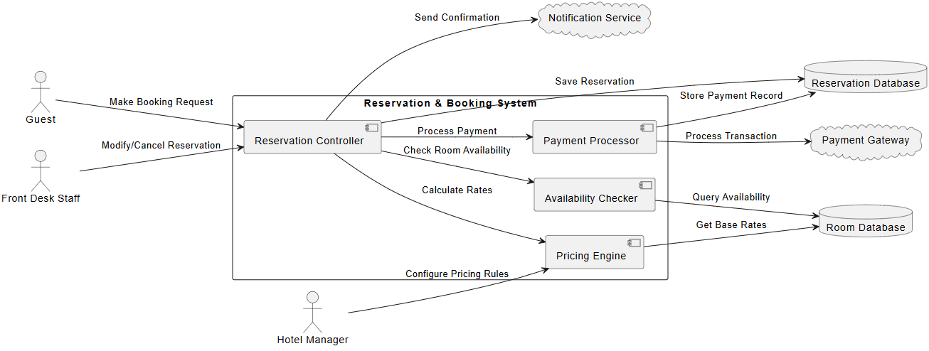

ACD 2: Room & Housekeeping Management Subsystem

This diagram shows how room status is managed and communicated between staff and the system to maintain operational efficiency.

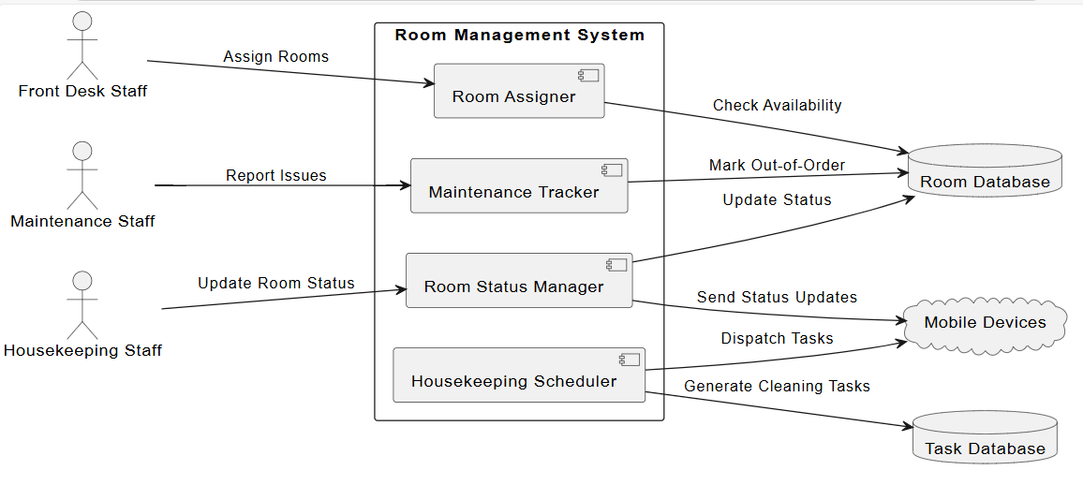

ACD 3: Guest Profile & Loyalty Management Subsystem

This diagram shows how guest data and loyalty programs are managed, providing personalized experiences and storing guest history.

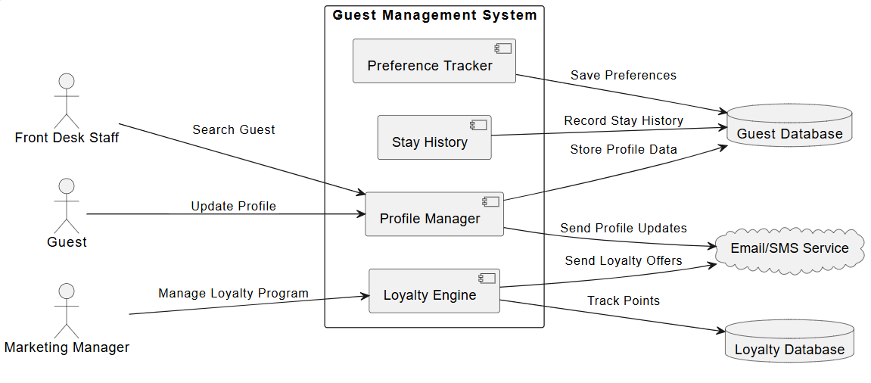

Section 3: Modularization

3.1 Partition of the Analysis Model
The QuickStay system has been partitioned into four key subsystems to manage complexity, enhance maintainability, and allow for parallel development. These subsystems are derived directly from the functional components identified in the SRS (Part A, Section 1.4).

Reservation & Booking Management Subsystem

- Purpose: Handles the entire guest reservation lifecycle.
- Core Classes: Guest, Reservation, Room, RoomType, Invoice, Payment
- Key Controllers: ReservationController, PaymentController
- Key Interfaces: PaymentGateway

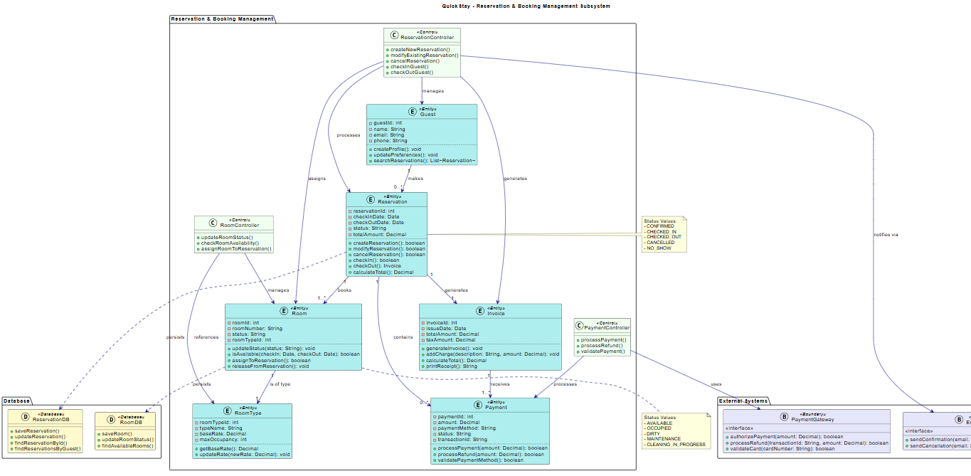

Link to Reservation & Booking Management Subsystem.

Room & Housekeeping Management Subsystem

- Purpose: Manages room inventory, status, and cleaning workflows.
- Core Classes: Room, HousekeepingTask, MaintenanceRequest
- Key Controllers: RoomManagementController, HousekeepingController
- Key Interfaces: SMSNotificationService

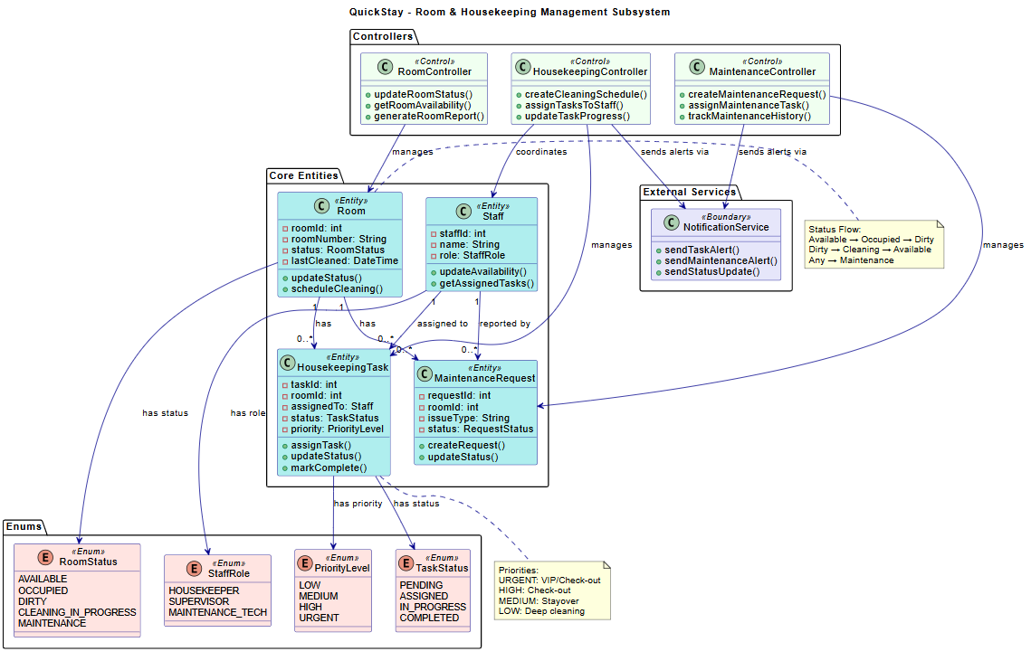

Link to Room & Housekeeping Management Subsystem

Guest Profile & Loyalty Management Subsystem

- Purpose: Manages guest data, preferences, and loyalty programs.
- Core Classes: Guest, LoyaltyProgram
- Key Controllers: GuestProfileController
- Key Interfaces: (Primarily internal data management)

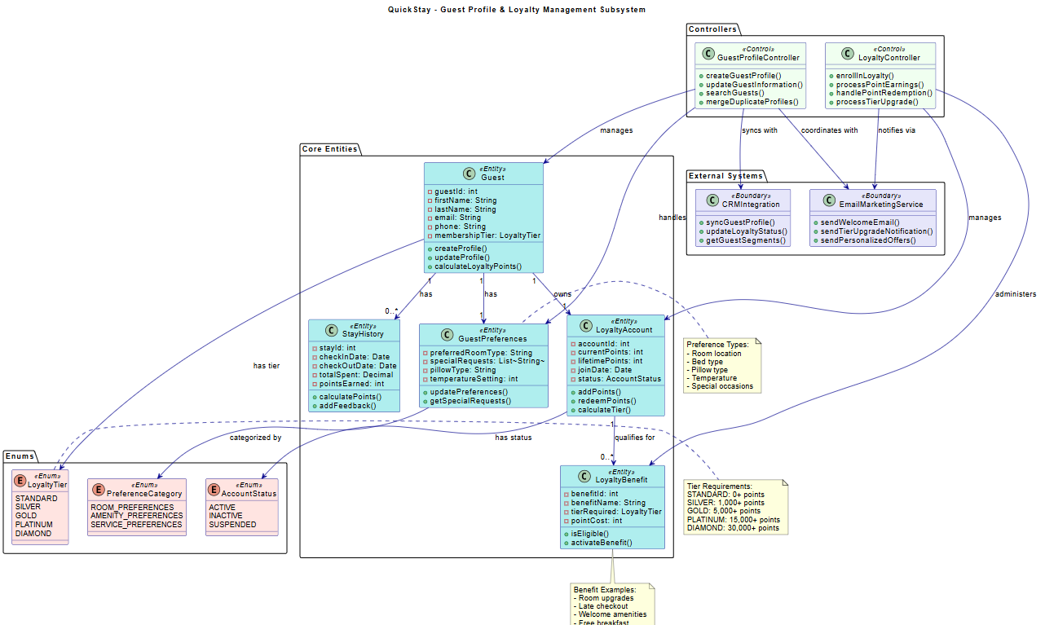Link to Guest Profile & Loyalty Management Subsystem

Staff & Administration Subsystem

- Purpose: Handles staff accounts, permissions, and system oversight.
- Core Classes: Staff, AuditLog
- Key Controllers: StaffManagementController, ReportController
- Key Interfaces: (Primarily internal data management and reporting)

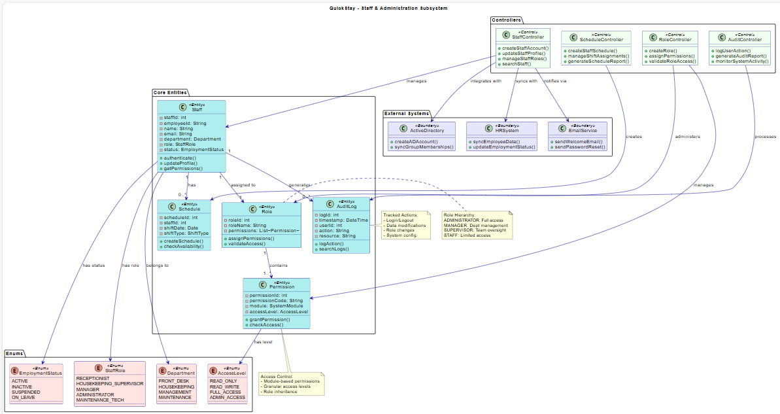
Link to Staff & Administration Subsystem

3.2 Class Responsibility Collaboration (CRC)

Reservation & Booking Management Subsystem

Class: Reservation
Super Classes: n/a | Sub Classes: n/a
Description: Represents a guest's booking. It ties together a guest, a room, and payment information for a specific date range.
Attributes
reservationId: int | Unique identifier for the reservation.
checkInDate: Date | The scheduled arrival date.
checkOutDate: Date | The scheduled departure date.
status: String | Current state (e.g., Confirmed, Checked-In, Checked-Out, Cancelled).
totalAmount: Decimal | The total cost of the stay.
Responsibilities | Collaborators
+ createReservation(): boolean | Guest, Room, Payment
+ modifyReservation(): boolean | Guest, Room, Payment
+ cancelReservation(): boolean | Payment
+ checkIn(): boolean | Room
+ checkOut(): Invoice | Invoice, Payment
+ calculateTotal(): Decimal | RoomType, Payment
Class: Room
Super Classes: n/a | Sub Classes: n/a
Description: Represents a physical hotel room with its attributes and current state.
Attributes
roomId: int | Unique identifier for the room.
roomNumber: String | The physical room number (e.g., "301").
status: String | Current state (e.g., Available, Occupied, Dirty, Out-of-Order).
roomTypeId: int | Reference to the type of room.
Responsibilities | Collaborators
+ updateStatus(status: String): void | HousekeepingTask
+ isAvailable(checkIn: Date, checkOut: Date): boolean | Reservation
+ assignToReservation(): boolean | Reservation
+ releaseFromReservation(): void | Reservation

Class: Payment
Super Classes: n/a | Sub Classes: n/a
Description: Handles all financial transactions related to a reservation.
Attributes
paymentId: int | Unique identifier for the payment transaction.
amount: Decimal | The amount of the transaction.
paymentMethod: String | The method used (e.g., Credit Card, Cash).
status: String | Current state (e.g., Pending, Completed, Refunded).
Responsibilities | Collaborators
+ processPayment(amount: Decimal): boolean | PaymentGateway
+ processRefund(amount: Decimal): boolean | PaymentGateway
+ validatePaymentMethod(): boolean | PaymentGateway

Room & Housekeeping Management Subsystem

Class: HousekeepingTask
Super Classes: n/a | Sub Classes: n/a
Description: Represents a cleaning or maintenance task assigned to housekeeping staff.
Attributes
taskId: int | Unique identifier for the task.
roomId: int | The room this task is for.
assignedTo: Staff | Staff member assigned to this task.
status: String | Current state (e.g., Pending, In Progress, Completed).
priority: String | Priority level (e.g., Low, Medium, High, Urgent).
Responsibilities | Collaborators
+ assignTask(staff: Staff): void | Staff
+ updateStatus(status: String): void | Room
+ markComplete(): void | Room, Staff
+ escalateTask(): void | Staff
Class: MaintenanceRequest
Super Classes: n/a | Sub Classes: n/a
Description: Tracks maintenance issues and repairs needed for rooms.
Attributes
requestId: int | Unique identifier for the request.
roomId: int | The room needing maintenance.
issueType: String | Type of issue (e.g., Plumbing, Electrical, HVAC).
status: String | Current state (e.g., Reported, In Progress, Resolved).
Responsibilities | Collaborators
+ createRequest(): void | Room
+ updateStatus(status: String): void | Room
+ assignTechnician(): void | Staff
+ markResolved(): void | Room

Guest Profile & Loyalty Management Subsystem

Class: Guest
Super Classes: n/a | Sub Classes: n/a
Description: Represents a hotel guest with personal information and preferences.
Attributes
guestId: int | Unique identifier for the guest.
firstName: String | Guest's first name.
lastName: String | Guest's last name.
email: String | Guest's email address.
phone: String | Guest's phone number.
membershipTier: String | Loyalty program tier.
Responsibilities | Collaborators
+ createProfile(): boolean | GuestPreferences
+ updateProfile(): boolean | GuestPreferences
+ calculateLoyaltyPoints(): int | LoyaltyAccount, StayHistory
+ upgradeTier(): boolean | LoyaltyAccount
Class: LoyaltyAccount
Super Classes: n/a | Sub Classes: n/a
Description: Manages guest loyalty points, tiers, and benefits.
Attributes
accountId: int | Unique identifier for the loyalty account.
currentPoints: int | Current available points.
lifetimePoints: int | Total points earned.
status: String | Account status (Active, Inactive, Suspended).
Responsibilities | Collaborators
+ addPoints(points: int): void | StayHistory
+ redeemPoints(points: int): boolean | LoyaltyBenefit
+ calculateTier(): String | Guest
+ getPointBalance(): int | Guest

Class: StayHistory
Super Classes: n/a | Sub Classes: n/a
Description: Tracks guest stay history for loyalty points and preferences.
Attributes
stayId: int | Unique identifier for the stay record.
checkInDate: Date | Arrival date.
checkOutDate: Date | Departure date.
totalSpent: Decimal | Total amount spent during stay.
pointsEarned: int | Loyalty points earned.
Responsibilities | Collaborators
+ calculatePoints(): int | LoyaltyAccount
+ addFeedback(feedback: String): void | Guest
+ getStayDuration(): int | Reservation

Staff & Administration Subsystem

Class: Staff
Super Classes: n/a | Sub Classes: n/a
Description: Represents hotel staff members with roles and permissions.
Attributes
staffId: int | Unique identifier for staff.
employeeId: String | Employee identification number.
name: String | Staff member's full name.
email: String | Work email address.
department: String | Department assignment.
role: String | Job role and permissions.
Responsibilities | Collaborators
+ authenticate(): boolean | Role
+ updateProfile(): boolean | StaffProfile
+ getPermissions(): List | Role, Permission
+ changePassword(): boolean | AuthenticationSystem
Class: Role
Super Classes: n/a | Sub Classes: n/a
Description: Defines staff roles and associated permissions.
Attributes
roleId: int | Unique identifier for the role.
roleName: String | Name of the role (e.g., Receptionist, Manager).
permissions: List | List of permissions granted.
Responsibilities | Collaborators
+ assignPermissions(): void | Permission
+ validateAccess(): boolean | Permission
+ cloneRole(): Role | Staff

Class: AuditLog
Super Classes: n/a | Sub Classes: n/a
Description: Records system activities for security and compliance.
Attributes
logId: int | Unique identifier for the log entry.
timestamp: DateTime | When the action occurred.
userId: int | Who performed the action.
action: String | What action was performed.
resource: String | What resource was affected.
Responsibilities | Collaborators
+ logAction(): void | Staff
+ searchLogs(): List | Staff
+ generateReport(): String | ReportingSystem

3.3 Design Classes Diagram
This section presents the detailed design class diagrams for each of the four main subsystems, showing attributes, methods, relationships, and navigability based on the CRC analysis.

Reservation & Booking Management Subsystem

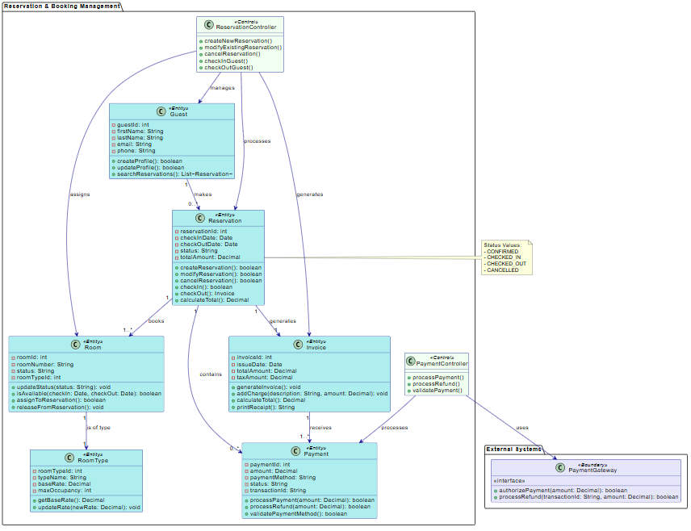
Reservation & Booking Management Subsystem

Room & Housekeeping Management Subsystem

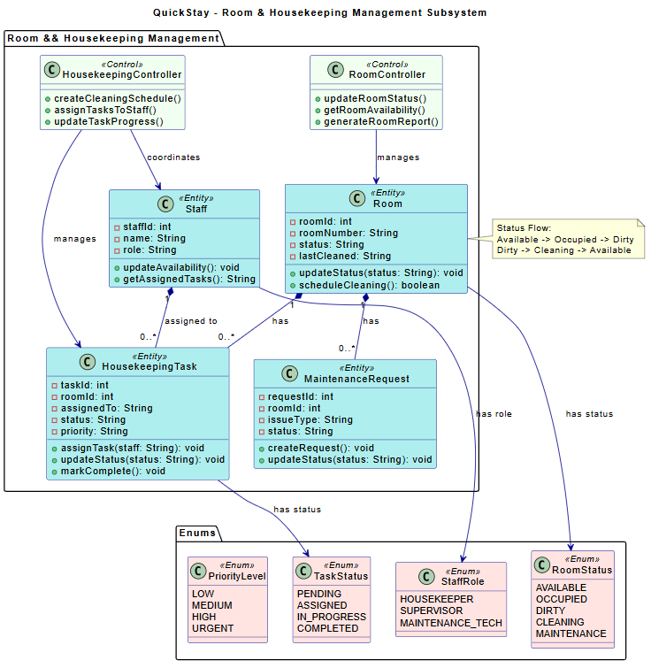
Link to Room & Housekeeping Management Subsystem

QuickStay - Guest Profile & Loyalty Management Subsystem
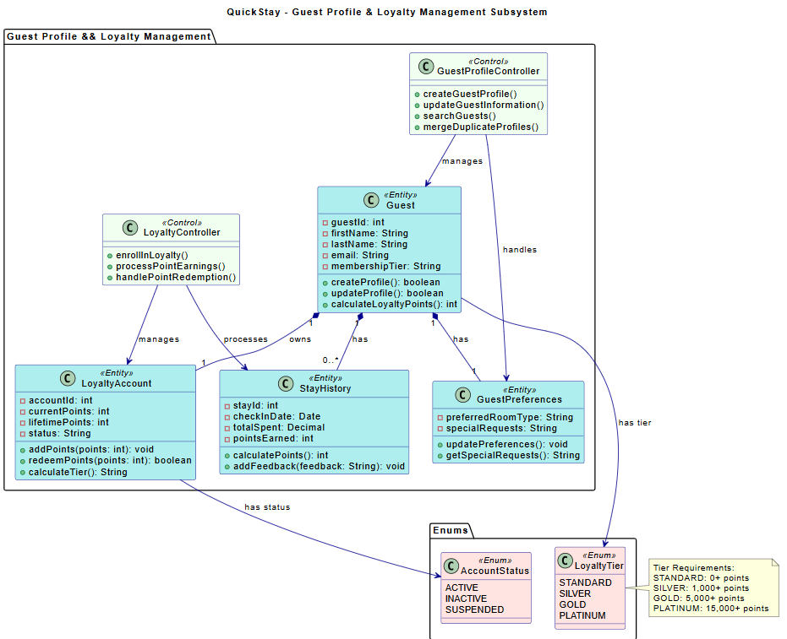
Link to Guest Profile & Loyalty Management Subsystem

Section 4: Framework Model View Controller

4.1 MVC Pattern Diagram

Reservation & Booking MCVP Pattern
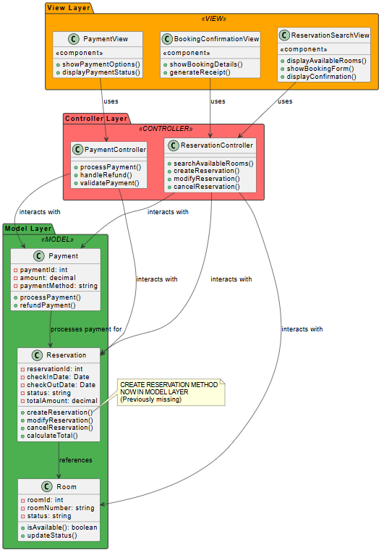

Room Management MVC Pattern

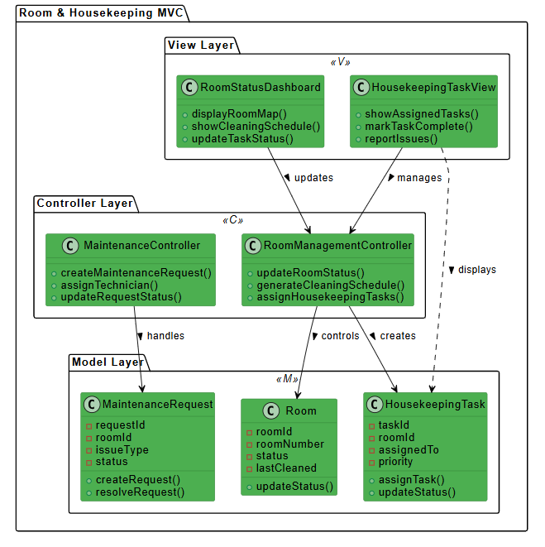

Guest Profile & Loyalty Management MCV

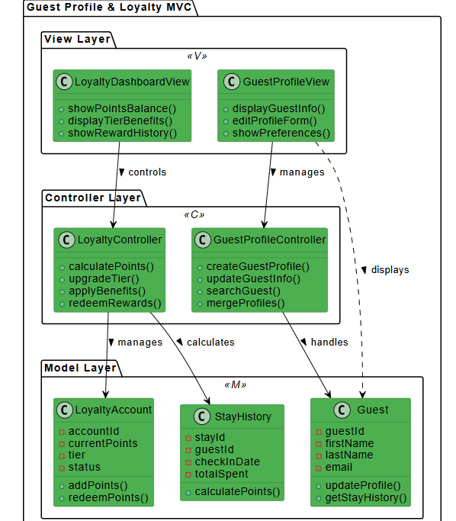

Staff & Administration MCV

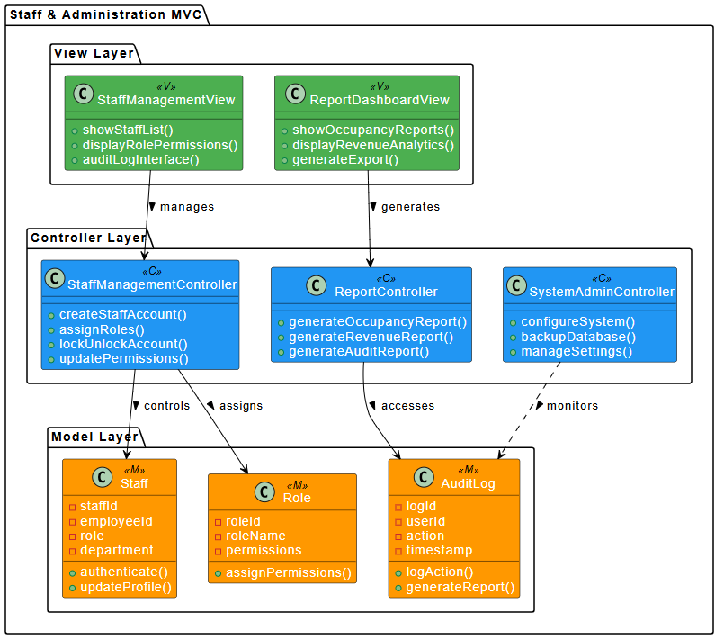

4.2 Sequence Diagrams (SD)

Make Reservation Sequence Diagram

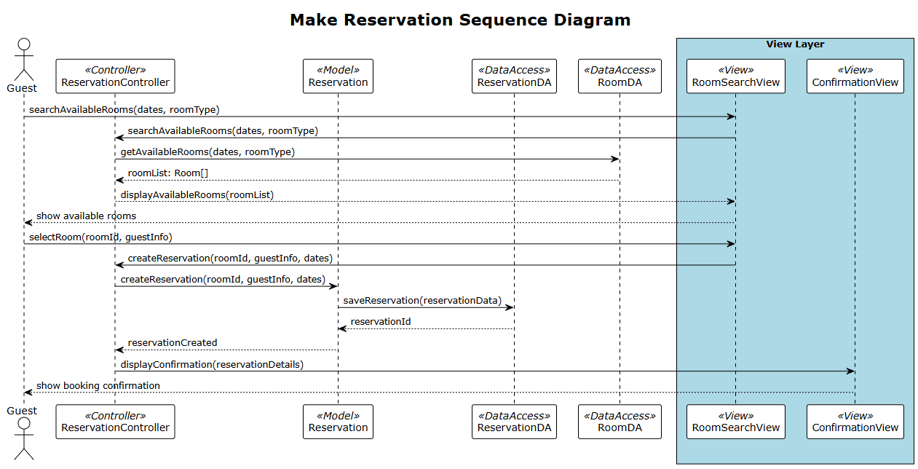

Process Payment Sequence Diagram

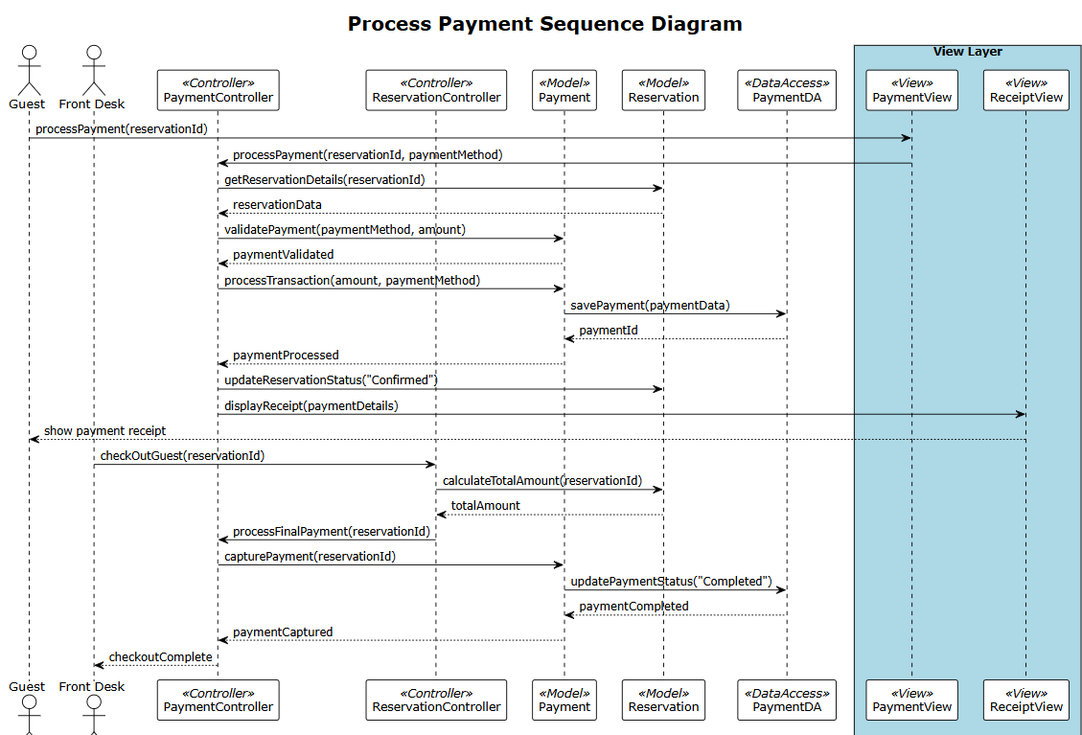

4.3 State Machine Diagrams

QuickStay Reservation Lifecycle SDM
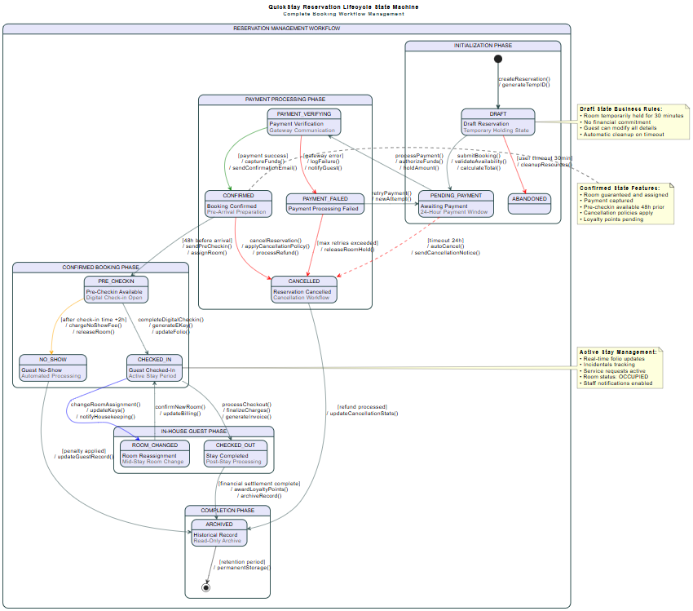

Room Status Management SMD

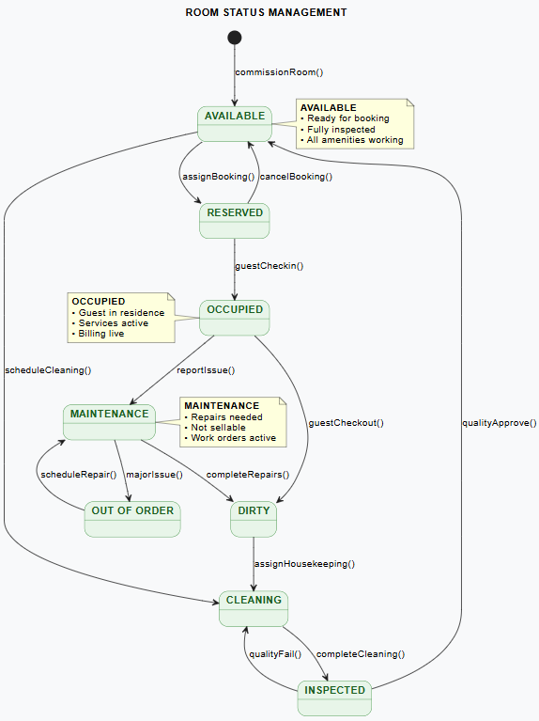

Link to Room Status Management SMD

Payment Transaction State Machine

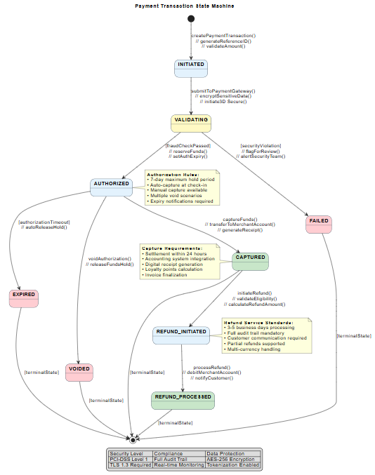
Link to Payment Transaction State Machine

Housekeeping Task State Machine

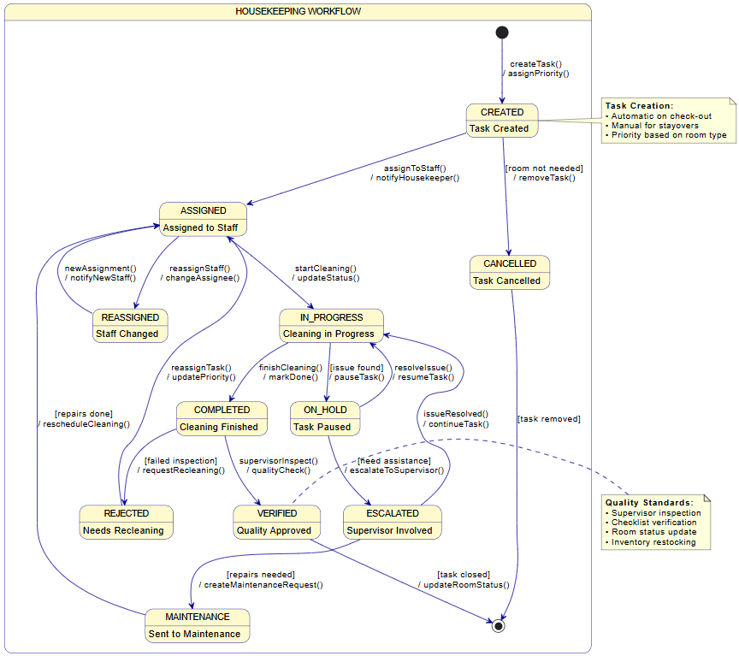
Link to Housekeeping Task State Machine

Section 5: Data Layer

5.1 Database Schema

-- =============================================
-- QUICKSTAY HOTEL MANAGEMENT SYSTEM
-- DATABASE SCHEMA

-- Core Entity Tables
CREATE TABLE Hotel (
hotel_id INT PRIMARY KEY IDENTITY(1,1),
hotel_name VARCHAR(100) NOT NULL,
address VARCHAR(255) NOT NULL,
city VARCHAR(50) NOT NULL,
country VARCHAR(50) NOT NULL,
phone VARCHAR(20),
email VARCHAR(100),
created_date DATETIME DEFAULT GETDATE()
);

CREATE TABLE RoomType (
room_type_id INT PRIMARY KEY IDENTITY(1,1),
type_name VARCHAR(50) NOT NULL,
description VARCHAR(255),
base_rate DECIMAL(10,2) NOT NULL,
max_occupancy INT NOT NULL,
amenities TEXT
);

CREATE TABLE Room (
room_id INT PRIMARY KEY IDENTITY(1,1),
room_number VARCHAR(10) NOT NULL,
hotel_id INT NOT NULL,
room_type_id INT NOT NULL,
floor INT,
status VARCHAR(20) DEFAULT 'AVAILABLE',
last_cleaned DATETIME,
FOREIGN KEY (hotel_id) REFERENCES Hotel(hotel_id),
FOREIGN KEY (room_type_id) REFERENCES RoomType(room_type_id)
);

-- User Management Tables
CREATE TABLE Guest (
guest_id INT PRIMARY KEY IDENTITY(1,1),
first_name VARCHAR(50) NOT NULL,
last_name VARCHAR(50) NOT NULL,
email VARCHAR(100) UNIQUE NOT NULL,
phone VARCHAR(20),
date_of_birth DATE,
created_date DATETIME DEFAULT GETDATE()
);

CREATE TABLE Staff (
staff_id INT PRIMARY KEY IDENTITY(1,1),
employee_id VARCHAR(20) UNIQUE NOT NULL,
first_name VARCHAR(50) NOT NULL,
last_name VARCHAR(50) NOT NULL,
email VARCHAR(100) UNIQUE NOT NULL,
phone VARCHAR(20),
department VARCHAR(50) NOT NULL,
role VARCHAR(50) NOT NULL,
hire_date DATE NOT NULL,
status VARCHAR(20) DEFAULT 'ACTIVE'
);

-- Reservation & Booking Tables
CREATE TABLE Reservation (
reservation_id INT PRIMARY KEY IDENTITY(1,1),
guest_id INT NOT NULL,
room_id INT NOT NULL,
check_in_date DATE NOT NULL,
check_out_date DATE NOT NULL,
status VARCHAR(20) DEFAULT 'CONFIRMED',
total_amount DECIMAL(10,2) NOT NULL,
created_date DATETIME DEFAULT GETDATE(),
FOREIGN KEY (guest_id) REFERENCES Guest(guest_id),
FOREIGN KEY (room_id) REFERENCES Room(room_id)
);

CREATE TABLE Payment (
payment_id INT PRIMARY KEY IDENTITY(1,1),
reservation_id INT NOT NULL,
amount DECIMAL(10,2) NOT NULL,
payment_method VARCHAR(50) NOT NULL,
payment_status VARCHAR(20) DEFAULT 'PENDING',
transaction_id VARCHAR(100),
payment_date DATETIME DEFAULT GETDATE(),
FOREIGN KEY (reservation_id) REFERENCES Reservation(reservation_id)
);

CREATE TABLE Invoice (
invoice_id INT PRIMARY KEY IDENTITY(1,1),
reservation_id INT NOT NULL,
issue_date DATETIME DEFAULT GETDATE(),
total_amount DECIMAL(10,2) NOT NULL,
tax_amount DECIMAL(10,2) NOT NULL,
discount_amount DECIMAL(10,2) DEFAULT 0,
final_amount DECIMAL(10,2) NOT NULL,
FOREIGN KEY (reservation_id) REFERENCES Reservation(reservation_id)
);

-- Housekeeping & Maintenance Tables
CREATE TABLE HousekeepingTask (
task_id INT PRIMARY KEY IDENTITY(1,1),
room_id INT NOT NULL,
assigned_to INT NOT NULL,
task_type VARCHAR(50) NOT NULL,
priority VARCHAR(20) DEFAULT 'MEDIUM',
status VARCHAR(20) DEFAULT 'PENDING',
scheduled_time DATETIME,
completed_time DATETIME,
notes TEXT,
FOREIGN KEY (room_id) REFERENCES Room(room_id),
FOREIGN KEY (assigned_to) REFERENCES Staff(staff_id)
);

CREATE TABLE MaintenanceRequest (
request_id INT PRIMARY KEY IDENTITY(1,1),
room_id INT NOT NULL,
reported_by INT NOT NULL,
issue_type VARCHAR(50) NOT NULL,
description TEXT,
priority VARCHAR(20) DEFAULT 'MEDIUM',
status VARCHAR(20) DEFAULT 'REPORTED',
reported_date DATETIME DEFAULT GETDATE(),
resolved_date DATETIME,
FOREIGN KEY (room_id) REFERENCES Room(room_id),
FOREIGN KEY (reported_by) REFERENCES Staff(staff_id)
);

-- Loyalty & Guest Preferences Tables
CREATE TABLE LoyaltyAccount (
account_id INT PRIMARY KEY IDENTITY(1,1),
guest_id INT UNIQUE NOT NULL,
current_points INT DEFAULT 0,
lifetime_points INT DEFAULT 0,
tier VARCHAR(20) DEFAULT 'STANDARD',
join_date DATETIME DEFAULT GETDATE(),
status VARCHAR(20) DEFAULT 'ACTIVE',
FOREIGN KEY (guest_id) REFERENCES Guest(guest_id)
);

CREATE TABLE GuestPreferences (
preference_id INT PRIMARY KEY IDENTITY(1,1),
guest_id INT NOT NULL,
preferred_room_type VARCHAR(50),
smoking_preference BIT DEFAULT 0,
special_requests TEXT,
pillow_type VARCHAR(50),
temperature_setting INT,
FOREIGN KEY (guest_id) REFERENCES Guest(guest_id)
);

CREATE TABLE StayHistory (
stay_id INT PRIMARY KEY IDENTITY(1,1),
guest_id INT NOT NULL,
reservation_id INT NOT NULL,
check_in_date DATE NOT NULL,
check_out_date DATE NOT NULL,
total_spent DECIMAL(10,2) NOT NULL,
points_earned INT NOT NULL,
feedback TEXT,
FOREIGN KEY (guest_id) REFERENCES Guest(guest_id),
FOREIGN KEY (reservation_id) REFERENCES Reservation(reservation_id)
);

-- Audit & System Tables
CREATE TABLE AuditLog (
log_id INT PRIMARY KEY IDENTITY(1,1),
user_id INT NOT NULL,
action_type VARCHAR(50) NOT NULL,
resource_name VARCHAR(100) NOT NULL,
old_values TEXT,
new_values TEXT,
ip_address VARCHAR(45),
timestamp DATETIME DEFAULT GETDATE()
);

CREATE TABLE SystemConfiguration (
config_id INT PRIMARY KEY IDENTITY(1,1),
config_key VARCHAR(100) UNIQUE NOT NULL,
config_value TEXT NOT NULL,
description VARCHAR(255),
last_updated DATETIME DEFAULT GETDATE()
);

-- Performance Indexes
CREATE INDEX IX_Reservation_GuestId ON Reservation(guest_id);
CREATE INDEX IX_Reservation_CheckInDate ON Reservation(check_in_date);
CREATE INDEX IX_Reservation_Status ON Reservation(status);
CREATE INDEX IX_Room_HotelId ON Room(hotel_id);
CREATE INDEX IX_Room_Status ON Room(status);
CREATE INDEX IX_HousekeepingTask_RoomId ON HousekeepingTask(room_id);
CREATE INDEX IX_HousekeepingTask_Status ON HousekeepingTask(status);
CREATE INDEX IX_Payment_ReservationId ON Payment(reservation_id);
CREATE INDEX IX_Staff_Department ON Staff(department);
CREATE INDEX IX_AuditLog_Timestamp ON AuditLog(timestamp);
CREATE INDEX IX_Guest_Email ON Guest(email);

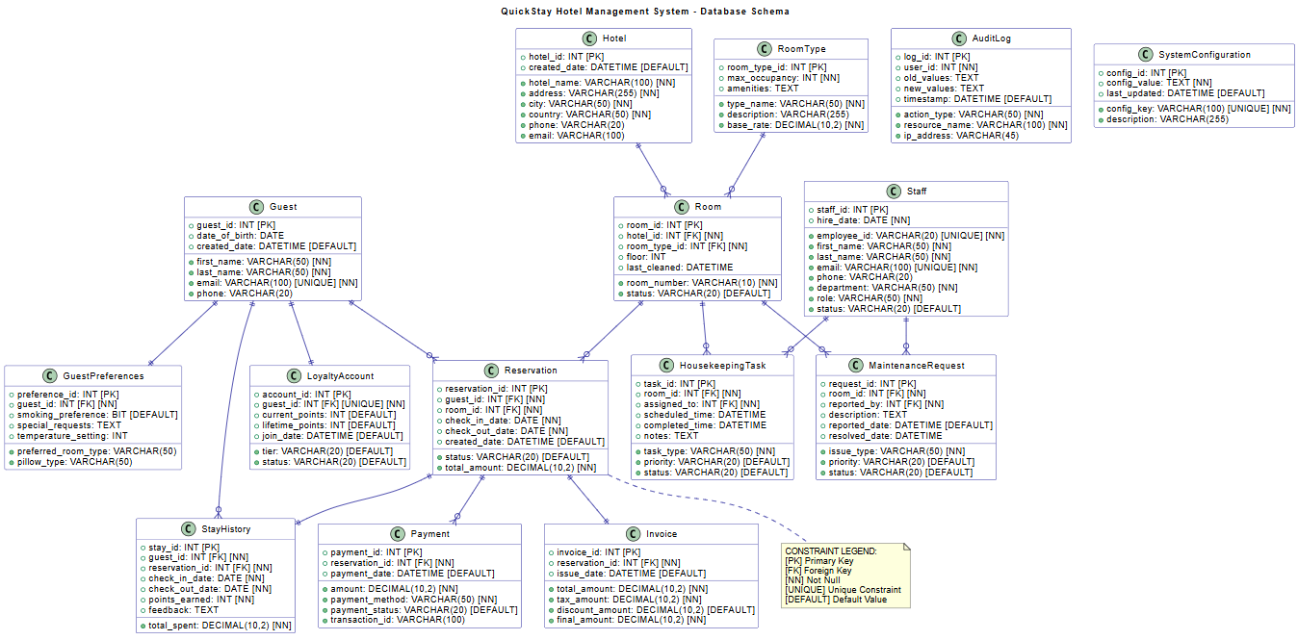
Link to Database Schema

5.2 Updated Technology List

Layer / Component | Technology | Version | Justification & Purpose
Presentation Layer (Front-end) | ASP.NET Core MVC | 6.0+ | Robust framework for building web applications with built-in security and scalability
 | HTML5, CSS3, JavaScript | Latest | Standard web technologies for a responsive user interface
 | Bootstrap | 5.0+ | CSS framework for consistent, mobile-first design
 | Razor Pages | 6.0+ | Server-side rendering for dynamic content generation
Application Layer (Back-end) | C# | 10.0+ | Strongly-typed, object-oriented language for business logic
 | ASP.NET Core Web API | 6.0+ | RESTful API for mobile app and external integrations
 | Entity Framework Core | 6.0+ | ORM for database operations and data modelling
 | ASP.NET Core Identity | 6.0+ | Authentication and authorization management
Data Storage Layer | Microsoft SQL Server | 2019+ | Enterprise RDBMS for transactional data and ACID compliance
 | Redis Cache | 6.0+ | In-memory data store for session management and caching
 | Azure Blob Storage | - | Cloud storage for documents and backups
External Services & APIs | Stripe API | Latest | Payment processing with PCI-DSS compliance
 | Twilio API | Latest | SMS notifications for bookings and reminders
 | SendGrid API | Latest | Email service for confirmations and marketing
 | Google Maps API | Latest | Location services and directions
Development & DevOps | Visual Studio 2022 | Latest | Primary IDE with comprehensive .NET support
 | Git / Azure DevOps | Latest | Version control and CI/CD pipeline
 | xUnit / NUnit | Latest | Unit testing frameworks
 | Moq | Latest | Mocking framework for testing
Hosting & Infrastructure | Microsoft Azure | - | Cloud platform for scalable hosting
 | Azure App Service | - | Platform for hosting a web application
 | Azure SQL Database | - | Managed cloud database service
 | Azure Application Insights | - | Application performance monitoring
Security | JWT Tokens | - | Secure API authentication
 | BCrypt / Argon2 | - | Password hashing algorithms
 | TLS 1.3 | - | Encrypted data transmission
Mobile Application | React Native | 0.70+ | Cross-platform mobile app development
 | Expo | Latest | Development platform for React Native
 | Redux Toolkit | Latest | State management for mobile app

Section 6: Grant Chart
